California State University Fullerton

CPSC 462



Object Oriented Software Design

Use Case Model – Annex 1

for the



Hotel Room Reservation

System

Reservation

Fully Dressed Use Case

|  |
| --- |
| **Allen Rivas** |
| Chief Technical Officer (CTO) |
| [allen.rrivas30@csu.fullerton.edu](mailto:allen.rrivas30@csu.fullerton.edu) |

Revision History:

| Version | Date | Summary of Changes | Author |
| --- | --- | --- | --- |
| 1.0 | March 23, 2021 | * First draft. To be refined primarily during the elaboration phase. | Allen Rivas |
| 1.1 | April 27, 2021 | * Update this draft with a new logo. Updated Main Success and Alternation Path Scenarios. Updated the system sequence diagrams for both Main and Alternative. | Allen Rivas |
| 1.2 | May 16, 2021 | * Updated this draft by adding change bars to indicate the changes that have been made. | Allen Rivas |

Table of Contents

1 Use Case Description 1

1.1 Use Case Title 1

1.2 Scope 1

1.3 Category 1

1.3.1 Risks addressed 1

1.4 Level 1

1.5 Primary Actor(s) 1

1.6 Stakeholders and Interests 1

1.6.1 Director 1

1.6.2 System Administrator 1

1.7 Preconditions (Entrance Criteria) 1

1.8 Success Guarantee (Exit State) 1

1.9 Main Success Scenario 1

1.10 Extensions (Alternate paths) 2

1.11 Special Requirements 2

1.12 Technology and Data Variations List 2

1.13 Frequency of Occurrence 2

1.14 Miscellaneous 2

2 System Sequence Diagrams 3

2.1 Making Reservation 3

2.1.1 Scenario Description 3

2.1.2 System Sequence Diagram 3

2.2 Canceling Reservation 4

2.2.1 Scenario Description 4

2.2.2 System Sequence Diagram 4

# Use Case Description

## Use Case Title

Maintain Reservation

## Scope

Hotel Room Reservation System

## Category

Architecturally Significant

### Risks addressed

1. ID: 4 and Hotel Rooms Unavailable

## Level

User goal

## Primary Actor(s)

* Guest

## Stakeholders and Interests

### Director

Update and make implementations to the system through the provided system features. Having the capabilities of retrieving information from the system that can be beneficial to the hotel in a business.

### System Administrator

Have scheduled updates that help provided more tools that help other users to customize the hotel room reservation system to their liking.

## Preconditions (Entrance Criteria)

Guest is required to have an account created under their personal information, if not then create one.

## Success Guarantee (Exit State)

Room reservation is saved. Room availability in system is updated. Confirmation is generated.

## Main Success Scenario

1. The guest requests to authenticate into the system providing name and password. The system responds with transaction ID.
2. The guest requests a list of rooms of available rooms providing the specifications of number of guests, arrival, and departure date. The system responds with a list of available rooms given the specifications (hotel, room type, cost per night, and total price).
3. The guest requests a list of services providing the specific hotel. The system responds with a list of services with cost.
4. The guest requests to make a reservation with a room providing hotel, type of room, number of guests, arrival and departure date, and amenities. The system responds with desired reservation.
5. The guest makes a request to pay for the reservation and provides guest name, credit/debit information (card number, expiration date, and CV). The system responds with a confirmed reservation number.
6. The guest requests to terminate session providing transaction ID. The system responds with termination.

## Extensions (Alternate paths)

1. The guest decides to cancel reservation.
   1. The guest requests to authenticate into the system providing name and password. The system responds with transaction ID.
   2. The guest requests reservation information by providing name, and confirmation number. The system responds with type of room, floor on which the room is on, and the room number.
   3. The guest requests to cancel reservation by providing name and confirmation number. The system responds with cancellation code.
   4. The requests to confirm cancellation of the reservation by providing the cancellation code. The system responds with indication that the reservation has been canceled.
   5. The guest requests to terminate session providing transaction ID. The system responds with termination.
2. The guest decides to change arrival and departure dates.
   1. The guest requests to authenticate into the system providing name and password. The system responds with transaction ID.
   2. The guest requests reservation information by providing name, and confirmation number. The system responds with type of room, floor on which the room is on, and the room number.
   3. The guest requests to change arrival and departure dates by providing name and confirmation number. The system responds with indication that the dates have been changed.
   4. The guest requests to terminate session providing transaction ID. The system responds with termination.

## Special Requirements

Login authorization response within 15 seconds 95% of the time.

## Technology and Data Variations List

1. Login information entered by keyboard.
2. Credit/Debit information entered by keyboard.

## Frequency of Occurrence

Frequency of occurrence would be at least 2,000 per day.

## Miscellaneous

Open issues on the system are, what customization is needed for different hotel businesses? Can the receptionist use the guest’s card information?

# System Sequence Diagrams

## Making Reservation

### Scenario Description

The guest will be making a reservation using the hotel room reservation system. The guest will login, search for a room with the specific criteria, reserve the room. Make a payment for the reservation and terminate the login session.

### System Sequence Diagram

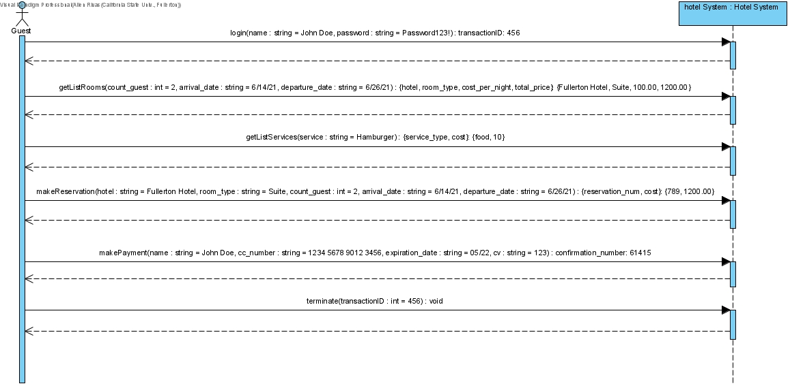

## Canceling Reservation

### Scenario Description

The guest will be canceling a reservation using the hotel room reservation system. The guest will login, search for their room and cancel the reservation. The guest finally terminates the login session.

### System Sequence Diagram

